Backend Development

* 2 Major Components

1. A programming language :- java, Javascript, PHP, Golang, C++ (choose one framework)
2. A Database :- Mongo, My Sql, Postgres, Sqlite

Browser

**Backend**

Mobile

Another Continent

Database (DB)

**Backend**

**A**

**P**

**I**

* A Javascript based Backend

We deal only three things

1. Data
2. File
3. Third Party (Api)

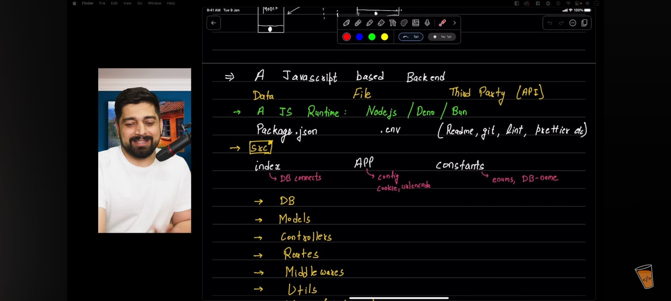

Index

App Files

Constants

DB (Database)

Models

Controllers

Routes Directory Structures (22:53 Chai Aur Backend 1st Video)

Middle wares

Utils (Utility)

More File (depends)